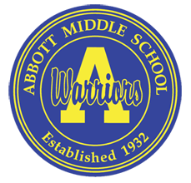

**ELEMENTARY 6TH GRADERS**

**COME JOIN ABBOTT MIDDLE FOR IT’S MIDDLE SCHOOL EXPERIENCE**

August 1st -August 3rd

Tuesday-Thursday

8:00am-12:00pm

 





IS A SUMMER SCHOOL PROGRAM DESIGNED TO PROVIDE STUDENTS WITH A FUN AND INNOVATIVE WAY TO TAP INTO THEIR CREATIVE ABILITIES…

* Mascot/Scavenger Hunt
* Escape Room
* Identity Circles
* STEM
* Mystery Mural
* Kahoot
* T-Shirt
* Locker Competition

**FOR MORE INFORMATION, QUESTIONS AND CONCERNS… PLEASE CONTACT**

**MS. PONQUINETTE 847-888-5163 (**[**nicoponquinette@u-46.org**](mailto:nicoponquinette@u-46.org)**)**

Identity Circles

STEM

Mystery Mural

Kahoot

T-Shirt

Locker Competition

FOR MORE INFORMATION, QUESTIONS

AND CONCERNS… PLEASE CONTACT MS. PONQUINETTE 847-888-5163 (Nico

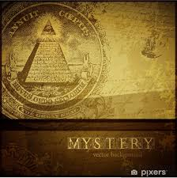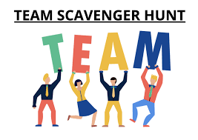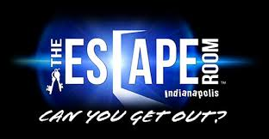

How do I sign up?

[**Click here**](https://district.u-46.org/SecondarySummerRegistration/login.cfm)🡪

Registration ends June 1, 2023